COMP6041 - Introduction to Databases
Assessment 3: PROJECT Design REport
Student Name: __LAIBA ASIF ___________________________________________________________
Student ID: ___R00201303___________________ Class Group: ___COMP1D-Y_______________

Design Phase Report
- List the Objects/Entities, Relationships and Multiplicities that represent the database system described in the Project Requirements section.
- Identify and list the Attributes for each of the Objects/Entities.
  - You must indicate any Primary, Foreign and Candidate keys.
- Draw a Class Diagram of the Database system.
Objects/Entities:
- Customer_details
- Purchase_order
- Product
- Merchants

Relationships:
- MERCHANTS_serves_ CUSTOMER DETAILS _places_ PURCHASE ORDER _refer to_ PRODUCT & MERCHANTS_sotres_ PRODUCT.
  - CUSTOMER DETAILS _one to many_ PURCHASE ORDER
  - Merchants_zero to many_ CUSTOMER DETAILS
  - CUSTOMER DETAILS_only one_Merchants
  - Merchants_zero to many_ Product
  - Product_only one_Merchants
  - PURCHASE ORDER _only one_ CUSTOMER DETAILS
  - PURCHASE ORDER _one to many_ product
  - Product _zero to many_ PURCHASE ORDER
Multiplicities:
  - CUSTOMER DETAILS _ (1:*)_PURCHASE ORDER
  - Merchants_(0:*)_ CUSTOMER DETAILS
  - CUSTOMER DETAILS_(1)_ Merchants
  - Merchants_(0:*)_ Product
  - Product_(1)_Merchants
  - PURCHASE ORDER _ (1)_CUSTOMER DETAILS
  - PURCHASE ORDER _ (1:*)_product
  - Product _ (0:*)_ PURCHASE ORDER

Attributes for Each of the Entities:
- CUSTOMER DETAILS:
- Customer_ID
- lname
- fname
- sex
- DOB
- phone_no.
- address
- City
- zipcode
- PURCHASE ORDER:
- order_ID
- Product_ID
- Customer_ID
- Order_data
- To_address
- To_city
- To_zipcode
- Total_cost
- PRODUCT:
- Product_ID
- Product_name
- Quantity
- Price
- Merchant_ID

- Merchants:
- Merchant_ID
- Lname
- Fname
- country

Class Diagram

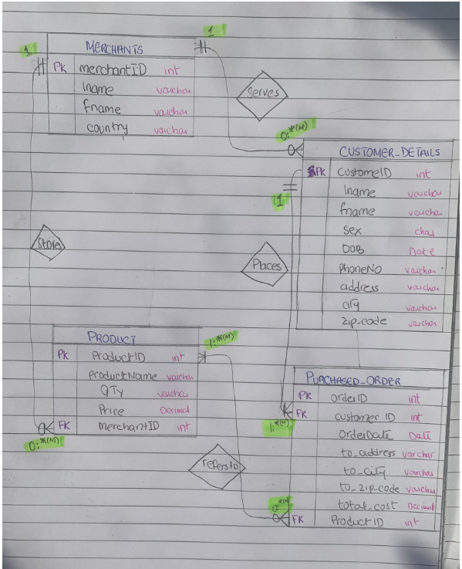

Additional Space:
You can state any assumptions for your database design here if you have not already done so in this report.

